Homework 4

1. Write and use a function integerPower that accepts two parameters, base and exponent, and returns the value: baseexponent. You can assume that exponent is a positive, nonzero integer and that base is an integer. Function integerPower should use a for loop to control the calculation. ***Do not use any math library functions.***
2. An integer is said to be prime if it's divisible by only 1 and itself. For example, 2, 3, 5, and 7 are prime, but 4, 6, 8, and 9 are not.
   1. Write a function that determines if a number is prime
   2. Use this function in a program that determines and prints all the prime numbers between 1 and 1,000.
3. Write a program that plays the game of "Guess the Number" as follows: Your program should choose a number to be guessed by selecting an integer at random in the range of 1 to 1000. The program then types:

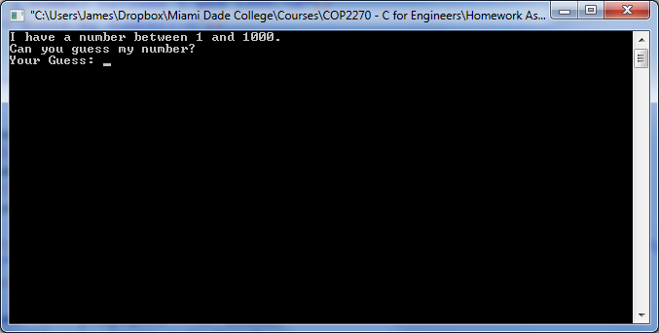

The player then types a guess. The program responds with one of the following:

1. Excellent! You guessed the number!  
   Would you like to play again (y or n)?
2. Too Low. Try Again.
3. Too High. Try Again.

If the player's guess is incorrect, your program should loop until the player gets the number right. Your program should keep telling the player Too High or Too Low to help the player "zero in" on the correct answer. *Note: Depending on how you code this program, you may run into the issue with scanf not grabbing the character value when the user types 'y' or 'n' because of the previous '\n' left in the input buffer from entering the number guess. If you do, try using something like:* **scanf("\n%c", &playAgain); // notice the explicit \n to consume**  
*We will discover better ways than this once we cover arrays and file i/o.*

See an example of the full program running on the next page:

